Pulses Seed-Hubs in India
State | # Seed-Hubs | State | # Seed-Hubs
Andhra Pradesh | 6 | Maharashtra | 11
Assam | 6 | Manipur | 2
Bihar | 10 | Nagaland | 1
Chhattisgarh | 7 | Odisha | 8
Gujarat | 8 | Punjab | 1
Haryana | 3 | Rajasthan | 14
Himachal Pradesh | 1 | Tamil Nadu | 8
Jharkhand | 5 | Tripura | 1
Jammu & Kashmir | 2 | Telangana | 5
Karnataka | 11 | Uttar Pradesh | 15
Kerala | 1 | Uttarakhand | 3
Madhya Pradesh | 16 | West Bengal | 5
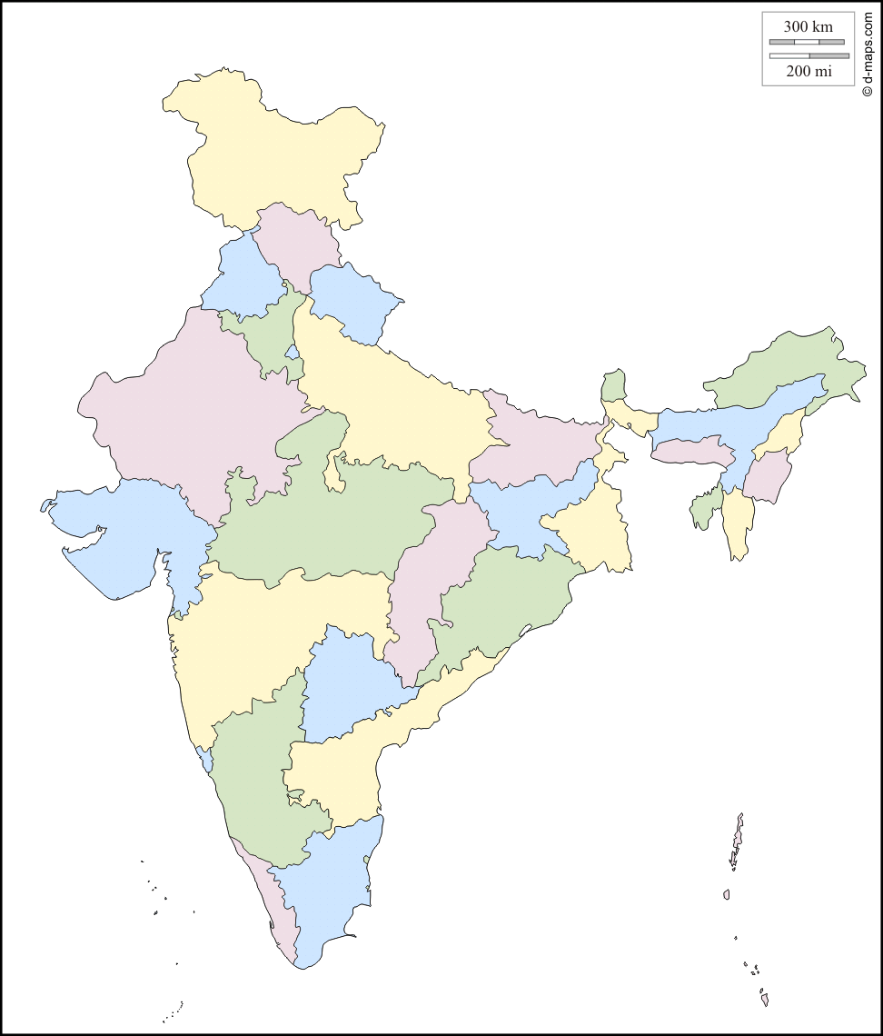
Total Seed Hubs : 150
ICAR Institutes: 7
AICRPs: 46
KVKs: 97
Map not to scale

Seed Hub

